**PAPER TITLE**

**A.F. Klmno 1 P.Q. Rstw 2,3 X. Yzabc 3 D. Efghi 4 J.K. Lmnop 4**

*1. Electrical Engineering Department, … University of …, City, Country, e-mail.account.1@---.---*

*2. Center of …, Faculty of Engineering, … University of …, City, Country, e-mail.account.2@---.---*

*3. Department of …, Organization of …, City, Country, e-mail.account.3@---.---*

*4. … Company, City, Country, e-mail.account@---.---, e-mail.account.4@---.---*

**Abstract-**Permanent magnet synchronous motor (PMSM) has a wide range of applications, such as electric drives and machine ………………………………

…………………………………………………………….

…………………………………………………………….

…………………………………………………………….

…………………………………………………………….

…………………………………………………………….

……………… to ensure stability and tracking. Simulations is carried out to verify the theoretical results.

**Keywords:**PMSM, Modeling, Saturation, ……………, …………., ……………., Lyapunov Stability.

**1. INTRODUCTION**

A broad spectrum of electric machines is widely used in electromechanical systems. In addition to the required …………………………………………………………….

…………………………………………………………….

…………………………………………………………….

…………………………………………………………….

*Follow the following instructions* 1-3 *to get high quality figures:*

**1. Change the picture(s) resolution**

Click File -> Options -> Advanced

Select:

**Image Size and Quality**

**√** Do not compress images in file

Default Resolution: **High Fidelity**

OK

**2. Check out the picture(s) resolution**

Click Picture Format -> Compress Pictures

Resolution: **High Fidelity**

**3.** If the picture(s) resolution **is not High Fidelity** then **CHANGE** it with high quality images.

…………………………………………………………….

…………………………………………………………….

…………………………………………………………….

…………………………………………………………….…………………………………………………………….

primary issues are studied in this paper. In particular, we perform nonlinear modeling and analysis, controllers design, and validate the theoretical results [1].

**2. MS WORD SHAPES**

Redraw the figures using the **MS Word graphical tools** to include the origin and high quality graphs in the paper.

**2.1. Flowcharts and Figures**

Draw the **Flowcharts** and related **Figure(s)** in the paper using the **MS WORD** *SHAPES* tool (*Insert >> Shapes* and then *Group* all of the shapes) to improve the quality of the image. **DRAW THE FIGURE(S) INSIDE THE MS WORD.**

Theory

Hypothesisis

Observation

Confirmation

Figure 1. Draw flowchart using MS Word Shapes tool style 1

Machine Tool

Electrical Energy

production

Raw material production

Energy

Material

Cooling fluid

and Tool preparation

...

Tool

Fluid

Product

Chip

Removed material processing system

boundary

CEchip

CEelec

CEm

CEfluid

CETool

Figure 2. Draw flowchart using MS Word Shapes tool style 2

*f*(*ν*)

*U*

*i*

*i*

Figure 3. Draw flowchart using MS Word Shapes tool style 3

**3. MS WORD CHARTS**

**3.1. Charts and Drawings**

Draw the **Charts** and related **Figure(s)** in the paper using the **MS WORD** *CHART* tool (*Insert >> Chart*) or DRAWING tool (*Drawing Tools*) to improve the quality of the image. **DRAW THE FIGURE(S) INSIDE THE MS WORD.**

Figure 4. Draw chart using MS Word Chart tool style 1

Figure 5. Draw chart using MS Word Chart tool style 2

Figure 6. Draw chart using MS Word Chart tool style 3

Figure 7. Draw chart using MS Word Chart tool style 4

**3.2. High Quality Figures**

The quality of **Figure(s)** with poor quality is not accepted and ***should be changed or redrawn*** by a high quality graphical tool(s). The quality of the figures in the journal published PDF format will be poor. Use the origin images with a qualitative resolution of **High Fidelity**.

Improve and upgrade the resolution and brightness of **Figure(s)** to high quality mode (or CHANGE them). The figures’ with poor resolutions and qualities are not acceptable. The figures and their contents should be clearly visible during zooming them. Enlarge the size of figures to make the included text visible.



Figure 8. Upgrade or redraw image in high quality resolution style 1



Figure 9. Upgrade or redraw image in high quality resolution style 1

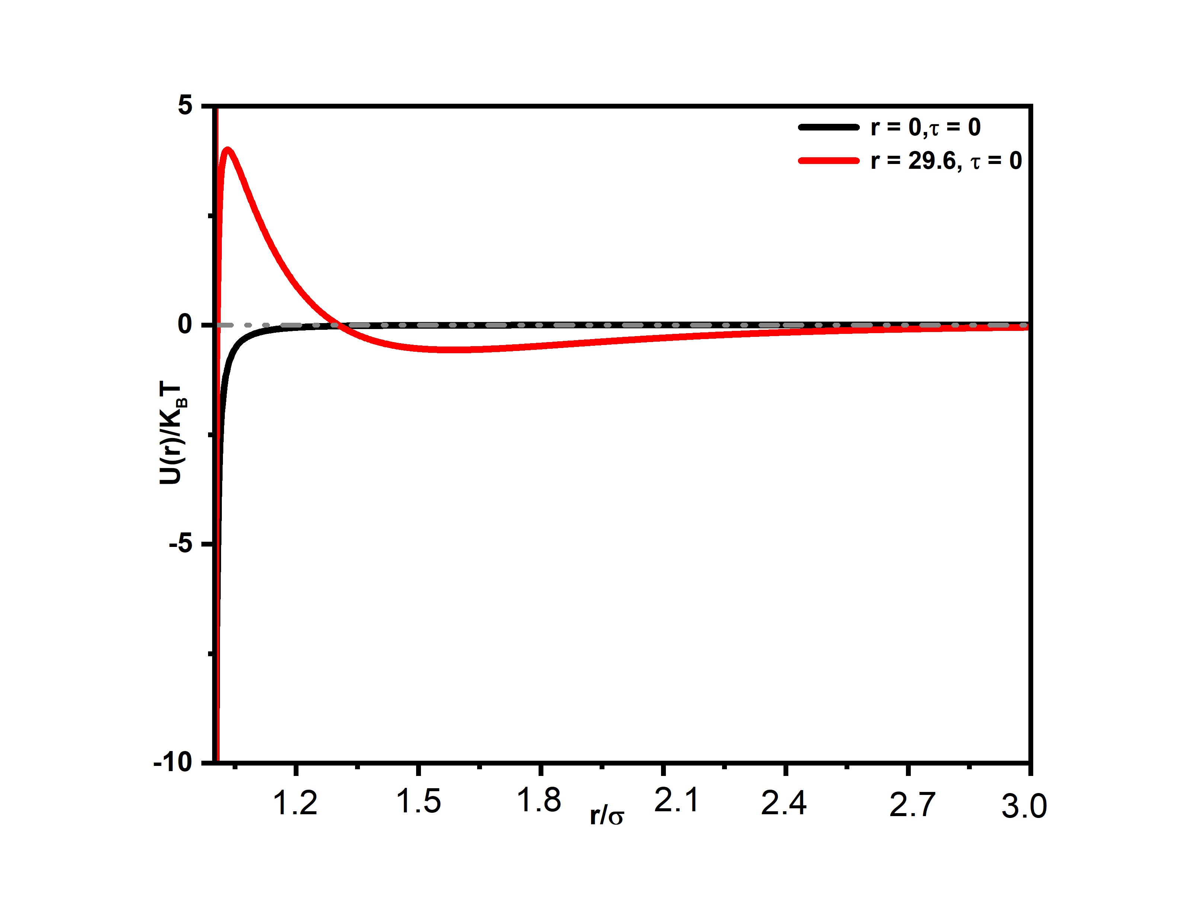

(a)

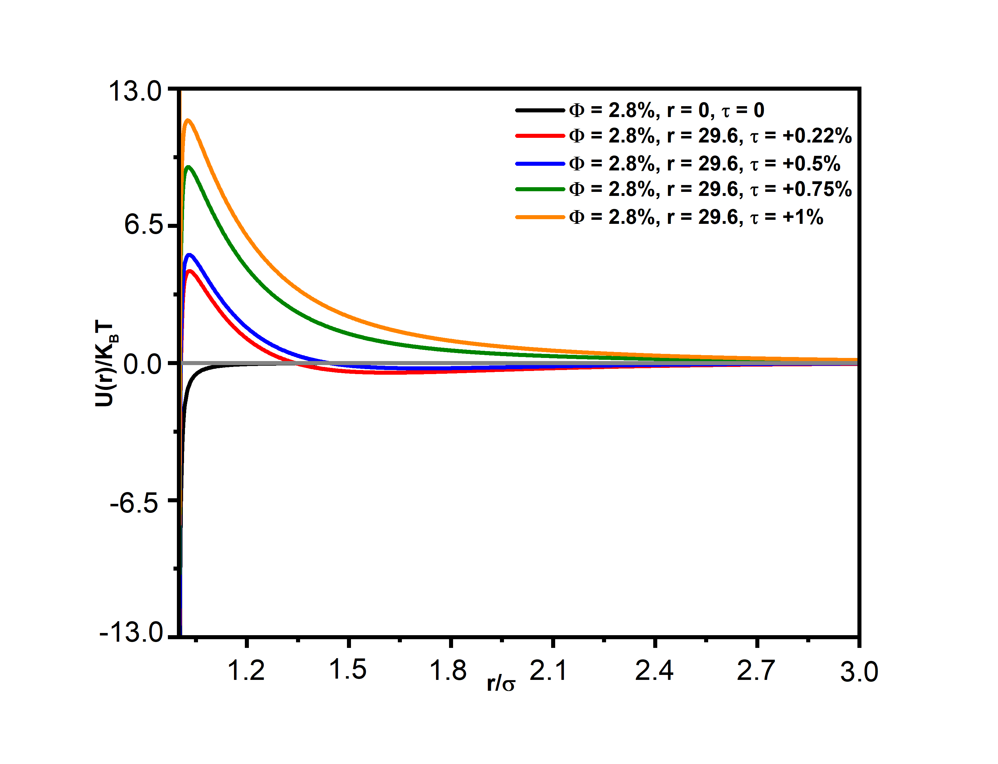

(b)

Figure 10. Upgrade or redraw image in high quality resolution style 2,

(a) Curves in condition 1, (b) Curves in condition 2

**4. EQUATIONS AND PARAMETERS**

**4.1. MathType Equation Editor**

- Type the **equations and parameters** in ***MathType Equation Editor 7 or later***, *ITALIC* format and *Times New Roman 10 pt*. The Numbers, parentheses and texts should be no Italic. The Equation Editor should be adjusted according to: Subscripts/Superscripts=70%, Sub-Subscripts/Superscripts=50%, Symbol=150%, Sub-Symbol=100%.

- The equations in the lower MathType version are not opened for editing.

- The equations and parameters to be typed in *Word Equation Tools* with Cambria Math *are not acceptable*.

**4.2. Sample Equations in MathType**

For the magnetically coupled abc stator windings, we apply the Kirchhoff voltage law to find a set of differential equations in **MathType Equation Editor**:

 (1)

 (2)

 (3)

 (4)

 (5)

where the flux linkages are:

 (6)

where,  is the stator resistance,  and  are the leakage and magnetizing inductances  and  is the amplitude of the flux linkages established by the permanent magnet.

**4.2. Conditions and Limitations of Typing the Equations and Parameters**

- The equations and parameters should be editable in MathType and need to rearrange them in right editable status. The equations should not be copied as ***images*** and *are not acceptable*.

- Write down all of the parameters of each equation together in a unique MathType environment. Do not use multiple ***MathType modules*** for one equation phrase.

- The equations should be editable in MathType and need to rearrange them in right editable status. The equations should not be copied as *images*.

🡪 Arrange all of ***the parameters*** in the text (which are not typed in MathType) in *ITALIC* format. ***The numbers, units and symbols*** like () should be NON-ITALIC.

- Type the equations and parameters in MathType Equation Editor, ***Italic* format and 8 pt** in the whole of the ***Tables and Figures***.

- Justify the *Equations on the left* and the *Equations numbers on the right*.

- Equations should be numbered beginning with (1) and placed in a separate line. Refer to the related equation numbers in the text body of the paper. It should be done according to the IJTPE format.

- Do not write down the numbers of the equations inside the MathType.

- Do not write down the numbers of the references in front of the equations. Write down the number of the references inside the [] at the end of the related paragraphs before the equations.

- Refer to all the equations by their numbers in the text body of the paper by using Equation (Number).

🡪 Do not use "*following*" or "*below*" for the equations, figures and tables. Use just equations, figures and tables numbers to address them in the text body of the paper.

- Rearrange the numbers of equations in a suitable place on the right side *out of the equations*.

- The equations *should not be placed* inside the *box format* or *table format* locations.

- Define all of the parameters used in the equations after each equation.

- Use the phrase of “*Equation*” instead of “*Formula*”, “*Expression*”, etc.

**5. STRUCTURES OF FIGURES, TABLES AND ALGORITHMS**

**5.1. Design of Figure(s), Table(s) and Algorithm(s)**

- Use the complete phrases of *Figure, Table and Equation* instead of *Fig., Tab. and Eq.* words.

- Change the font and size of all the information, *equations and titles* in the *tables, figures and algorithms* to *Times New Roman 8 pt*.

- The **Figure(s), Table(s) and Algorithm(s)** should be **simple design**, **not bordered**, **not shadowed, not highlighted** and **not bolded** as well as including *high quality/resolution* contents and *Times New Roman 8 pt - black color*.

- The **Table(s)** should be simple design, no highlighted and black color with a border width of 0.5 pt around all of the rows and columns.

- **Type** the contents of **Table(s)**. The Tables in *graphical/image* status *are not acceptable*.

- Remove the border lines around of the figures.

- Adjust the cutting edges of **Figure(s)** to protect the removed letters in the edges.

**5.2. Number of Figure(s), Table(s) and Algorithm(s)**

- Do not use **()** for the numbers of **Figure(s), Table(s) and Algorithm(s)**.

- Assign the numbers to the figures and tables beginning with 1 and refer to the related numbers in the text body of the paper. It should be done according to the IJTPE format.

- Correct the numbers of the figures/tables from Romans numerals to numbers beginning with 1.

🡪 Refer to all the Figure(s), Table(s) and Algorithm(s) by their numbers in the text body of the paper.

🡪 Refer to all the Figure(s), Table(s) and Algorithm(s) by their numbers in the text body and also in the **down/top/top** of the **Figure(s)/Table(s)/Algorithm(s)** by using the Number(s).

- Check out the *number of figures and tables* should be continuously assigned. There are some repeated numbers in the paper.

**5.3. Position of Figure(s), Table(s) and Algorithm(s)**

- Do not put the title of the figures and tables in the boxes. Use "In Line with Text" for Wrapping for the titles and fix their locations in the text.

- Change the background color of the figures to white.

🡪 Set the Wrap Text of all **Figures** to “***in Line with Text***” via Picture Format toolbar.

🡪 Set the Text Wrapping of all **Tables/Algorithm** to “***None***” via Table Properties menu.

Table 1. Load demand of modified IEEE 16 bus [30]

|  |  |  |  |  |  |
| --- | --- | --- | --- | --- | --- |
| Zone | *PL*  (kW) | *QL*  (kVAR) | Zone | *PL*  (kW) | *QL*  (kVAR) |
| 1 | 5004.56 | 2006.26 | 6 | 4500 | -1700 |
| 2 | 2000 | -400 | 7 | 2001.23 | -198.34 |
| 3 | 1500 | 1200 | 8 | 1000 | 900 |
| 4 | 5001.23 | 3601.23 | 9 | 2100 | -800 |
| 5 | 5600.41 | 1300.41 |  |  |  |

Table 2. Thermal Insulation Performance of Cannabis Fiber Samples

|  |  |  |  |
| --- | --- | --- | --- |
| Sample | Thermal Conductivity (W/mK) | R-Value (m²K/W) | Heat Retention Capacity |
| Bast Fiber Sample | 0.032 | 3.125 | 95.2 |
| Core Fiber Sample | 0.040 | 2.500 | 87.6 |

- Type the equations and parameters in MathType Equation Editor, ***Italic* format and 8 pt** in the whole of the ***Tables and Figures***.

- The Numbers, parentheses and texts should be no Italic. - The Equation Editor should be adjusted according to: Subscripts/Superscripts=70%,

Sub-Subscripts/Superscripts=50%,

Symbol=150%, Sub-Symbol=100%.

Table 3. Technical characteristics of the research object

|  |  |  |
| --- | --- | --- |
| Description, sizes | Symbol | Value |
| Length in between perpendiculars, m | *Lbp* | 28.80 |
| Length in waterline, m | *Lw*1 | 29.97 |
| Overall breadth, m | *B* | 6.35 |
| Middle draft, m | *d* | 1,94 |
| Fore draft, m |  | 1.94 |
| Aft draft, m | *da* | 1.94 |
| Weight displacement, t | Δ | 248.58 |
| Volume displacement, m3 | ∇ | 245.63 |
| Overall completeness coefficient | *Cb* | 0.641 |
| Mid frame completeness coefficient | *Cm* | 0.962 |
| Waterline completeness coefficient | *Cw* | 0.799 |
| Watered surface area, m2 | *S* | 222.97 |

Algorithm 1. Proposed monitoring system

|  |
| --- |
| Input: *B*1[ ] (Banned snapshots), *B*2[ ] (Banned videos), *Img*[ ] (Passer images), *F* (Banned Information file)  Output: *E_msg* (Alert message), *M_msg* (Monitor notification)  Begin  Construct (*B*1, *B*2, *MDB*, *WDB*);  While ∃ *Ph* ∈ *Img* & *Permit* ( ) do  Read (*Ph*);  Preprocess (*Ph*);  Detect (*E*-*F*);  Extract (*F*, *Wt*);  Classify (*G*);  If G == '*M*' then  Match (*Wt*, *MDB*);  Else  Match (*Wt*, *MDB*);  End If;  Compute (*S*);  If S ≠ *λ* then  Display (“Unknown”);  Else  Get (*Id*);  Readf (*F*, *Id*, *G*, *N*, *B*, *C*, *S*, *E*);  *E_msg* = “*Prevent*” + *N*;  SendE (*E_msg*, *N*, *Id*, *Loc_B*, *Loc_I*, Date ( ), Time ( ));  Display (*M_msg*, *Id*, *Img*, *G*, *N*, *B*, *C*, *S*, *E*);  End If;  End while;  End |

# 6. SIMULATION RESULTS

In this section, we design a tracking controller for a electromechanical system. We use a Kollmorgen four-pole permanent-magnet synchronous motors H-232 with the following rated data and parameters: 135 W, 434 rad/sec, 40 V, 0.42 N.m, 6.9 A, , ,or 

and 

…………………………………………………………….

…………………………………………………………….

…………………………………………………………….

…………………………………………………………….

…………………………………………………………….

…………………………………………………………….

This controller is bounded. The sufficient criteria for stability are satisfied. To study the transient behavior, a controller is verified through comprehensive simulations. Different reference velocity , loads , and initial conditions

Figures 11 and 12 illustrate the system power distribution and effect of Ti concentration on FeCrAl steel.

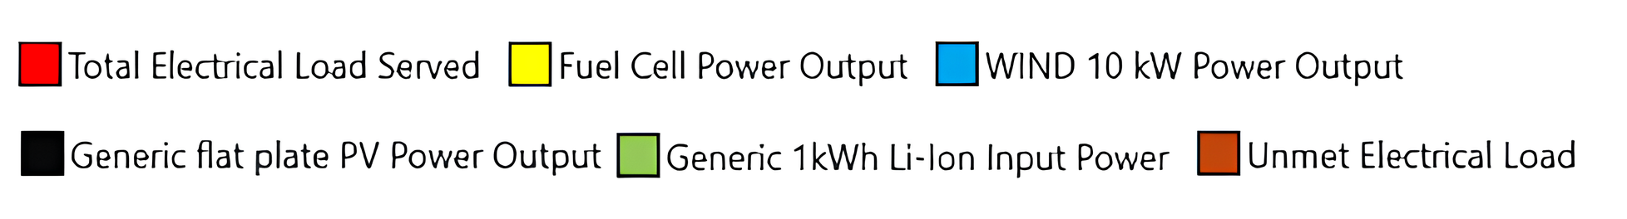

Figure *11*. System power distribution

Figure 12. Effect of Ti concentration on FeCrAl steel

**7. CONCLUSIONS**

Permanent-magnet synchronous motors are used in a wide range of electromechanical systems because they are simple and can be easily controlled. The steady-state torque-speed characteristics fulfil the controllability criteria over an entire envelope of operation. In this paper a bounded controller is designed and sufficient criteria for stability are satisfied. Different reference velocity, loads, and initial conditions are studied to analyze the tracking performance of the resulting system.

…………………………………………………………….

…………………………………………………………….

…………………………………………………………….

**AppendiCES**

## Appendix 1. Construction Cost and Characteristics of 230 and 400 kV Lines

Tables 4 and 5 show the construction costs of 230 and 400 kV lines. Also, the characteristics of these lines are listed in Table 6.

Table 4. Construction cost of 230 kV

|  |  |  |
| --- | --- | --- |
| Variable Cost of Line Construction  (×103 dollars) | Fix Cost of Line Construction  (×103 dollars) | Number of Line Circuits |
| 45.9 | 546.5 | 1 |
| 63.4 | 546.5 | 2 |

Table 5. Construction cost of 400 kV

|  |  |  |
| --- | --- | --- |
| Variable Cost of Line Construction  (×103 dollars) | Fix Cost of Line Construction  (×103 dollars) | Number of Line Circuits |
| 92.9 | 1748.6 | 1 |
| 120.2 | 1748.6 | 2 |

Table 6. Characteristics of 230 kV lines

|  |  |  |  |
| --- | --- | --- | --- |
| Resistance (p.u/Km) | Reactance (p.u/Km) | Maximum Loading (MVA) | Voltage Level |
| 1.22e-4 | 3.85e-4 | 397 | 230 |
| 3.5e-5 | 1.24e-4 | 750 | 400 |

## Appendix 2. GA and Other Required Data

## Load growth coefficient = 1.08; Inflation coefficient for loss = 1.15; Loss cost in now = 36.1 ($/MWh); Number of initial population = 5; End condition: 3500 iteration after obtaining best fitness (N=3500); LLmax = 30%.

…………………………………………………………….

…………………………………………………………….

…………………………………………………………….

…………………………………………………………….

…………………………………………………………….

…………………………………………………………….

…………………………………………………………….

…………………………………………………………….

…………………………………………………………….

…………………………………………………………….

…………………………………………………………….

# NOMENCLATURES

**1. Acronyms**

CHCPCombined Heat, Cooling and Power

CHPCombined Heat and Power

COPCoefficient of Performance

DGDistributed Generation

**2. Symbols / Parameters**

**: The number of gas and heat units

**: The number of water units

**: The whole production expense

**: The fuel expense of its unit

*:* The load of net in *t* moment

*:* The cycling reserve load

*:* The production power of *i* heat unit

*:* The production power of *j* water unit

*:* The reserve power of *i* water unit

*:* The reserve power of *j* water unit

*:* The starting expense of *i* heat unit

*:* The starting expense of *j* water unit

**: The subtitle related to interval

**: The time of a complete period under consideration

**ACKNOWLEDGEMENTS**

The author(s) sincerely thank …, Department of Abcd, Faculty of Efgh, University of Ijkl, City, Country for assisting with ...

The author(s) appreciate the assistance of the staff of the Abcd University, City, Country for supporting …

Special thanks go to …

The author(s) grateful to / extend their gratitude to / would like to thank / gratefully acknowledge …

**REFERENCES**

[1] G.A. Taylor, M. Rashidinejad, Y.H. Song, M.R. Irving, M.E. Bradley, T.G. Williams, “Algorithmic Techniques for Transition Optimized Voltage and Reactive Power Control”, International Conference on Power System Technology, Vol. 3, No. 2, pp. 1660-1664, 13-17 Oct. 2002.

[2] J. Zhong, E. Nobile, A. Bose, K. Bhattacharya, “Localized Reactive Power Markets Using the Concept of Voltage Control Areas”, IEEE Transactions on Power Systems, Vol. 19, Issue 3, pp. 1555-1561, Aug. 2004.

[3] A.B. Author1, “Title of the Book”, Ghijk Press, City, Country, Year.

[4] A. Author1, C.D Author2, “Title of the Conference Paper”, 8th International Conference on Technical and Physical Problems of Electrical Engineering (ICTPE-2013), No. 10, Code 01CPE05, pp. 42-48, City, Country, 9-11 September 2013.

[5] A.B. Author1, C. Author2, D.E.F. Author3, “Title of the Journal Paper”, International Journal on Technical and Physical Problems of Engineering (IJTPE), Issue 12, Vol. 4, No. 3, pp. 79-86, September 2012.

[6] http://www.abcd.efgh_ijk.LMN/.../opqr.pdf.

*- Include the photo(s) of the author(s) with high quality and color based in the Biographies section. The photos should be in high resolution, color status and size of 2.5×2 cm. Taken in full-face view directly facing the camera.*

*Improve the poor quality of the author(s)’ photo(s) using IMAGE ENHANCER tools/services.*

Resolution: **High Fidelity**

*-* *Fill in the items of the following form for all of the authors* *separately at the end of the paper.*

**BIOGRAPHIES**

|  |
| --- |
| Name: **Abcde**  Middle Name: **Fghij**  Surname: **Klmno**  Birthday: dd.mm.yyyy  Birthplace: City, Country  Bachelor: Field/Title, Department, Faculty, University/Institute, City, Country, Year of Graduation  Master: Field/Title, Department, Faculty, University/Institute, City, Country, Year of Graduation  Doctorate: Field/Title, Department, Faculty, University/Institute, City, Country, Year of Graduation  The Last Scientific Position: Academic/Prof./Assoc. Prof./Assist. Prof./Lecturer/(Bachelor/Master/Doctorate) Student, Department, Faculty, University/Institute, City, Country, Since Year  Research Interests: Field 1, Field 2, Field 3  Scientific Publications: ? Papers, ? Books, ? Patents, ? Projects, ? Theses  Scientific Memberships: Organization 1, Organization 2, Organization 3 |

**Select one Conference Topic for your submitted paper from the following link:**

<http://www.iotpe.com/ICTPE/ICTPE-2020/ConferenceTopics.html>

e.g.: **1. Power and Energy Systems (01PES)**